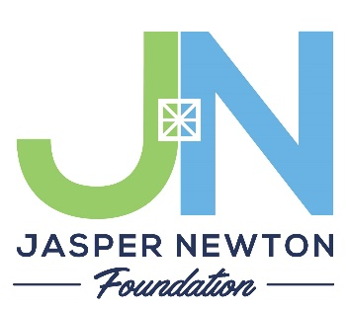
COMMUNITY GRANTS 2022

Application Checklist and Cover Sheet

Submission Guidelines

2022 Community Grant Applications are DUE APRIL 1, 2022. This is the only cycle of traditional community grants for 2022 and grant request amounts must be $5,000 or less. Please submit your grant application and all attachments via email to Ashley Hughes by 5 pm central time on Friday, April 1. Please type your application if possible so it is easier for the grants committee to review. Also please save files in PDF format even if you attach multiple files.

Email your grant application and all attachments to Ashley Hughes, Program Director, at ahughes@jasperfdn.org. After submission, you will receive a confirmation email that your application was received, which will include a timeline for your grant review.

Checklist for Submission

I have called the JNF office to speak with the Executive Director about my grant if this is my first grant or if salary dollars are being requested. (Not required for all applicants.)

I have filled out the grant cover sheet and Board of Directors questions.

I have included my Board of Directors listing with officers and contact information.

I have included my Program/Project Budget including as much detail as possible.

I have included a 1-2 paragraph Budget Narrative explaining our budget expenses.

I have included my organization’s balance sheet and this year’s operations budget.

I have attached a letter from my CEO, President, or Board Chair expressing their knowledge and support of this grant application. **If you are the President – please provide board minutes of approval for this grant application.

I have fully answered the 7 Grant Narrative Questions.

If awarded, I will complete the Final Grant Report as requested by the JNF office staff.

I, __________________________________, certify that I have read and filled out this grant application to completion and followed all the requested steps.

Signature ___________________________________, title _________________________

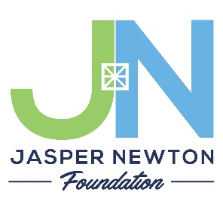
COMMUNITY GRANTS 2022
Application
JASPER COUNTY COMMUNITY FUND
NEWTON COUNTY COMMUNITY FUND
(circle one fund only)

Organizational Information

Legal Name of the Organization
Telephone Number
Website Address
Street Address of Organization
City | State |  | Zip
Mailing Address
(if different than physical address)
City | State |  | Zip
Federal Tax ID (EIN)
Main Contact Person for Grant
Contact Phone Number
Contact Email Address

Program Description
Please include a 2-3 sentence summary of the program you are requesting community grant dollars for in the box below. This should be clear and concise.

What area of the community does this grant application seek to serve the most?
____ Vibrant Community (Arts, Culture, Lifestyles)
____ Prosperous Community (Business Development Resources, Employee Training)
____ Quality Life (Access to Health Care & Healthy Life Choices)
____ Kids & Families (Education)

Board of Directors Information

Board Chair or President
Telephone Number
Email Address

**Please attach a listing of your current Board of Directors, indicate officer roles, and include a phone number or email address for contacting each member.

What percentage of the Board of Directors contributed any amount of dollars to this organization in the most recent fiscal year?

What percentage of the Board of Directors made an in-kind contribution to this organization in the most recent fiscal year?

What percentage of your Board of Directors volunteer their time beyond attending board meetings?

Have any members of the Board of Directors participated in non-profit training (e.g. board development, fundraising, grant writing, etc.) during the past year?
What kind of training did they receive?

Grant Budget & Budget Narrative

Your grant budget is an important tool for communicating your project to the JNF Grants Committee. We are asking for more detail this year in your application. Please provide the entire project budget and scope – even if you are only asking JNF for a portion of the project budget itself. The more we can understand about the larger purpose of your whole project the better we can evaluate the partnership of Jasper Newton Foundation.

If you are securing goods or services, please provide at least 2 quotes (if possible) for these goods and services. We want to see that you are being resourceful in your local relationships and in your goals of remaining fiscally responsible for your charitable dollars. If you are purchasing most of your products online, you will need to provide 2 pricing quotes. You can do this easily by taking a screen shot or printout of the website shopping cart.

Salary dollars being requested must flow directly to the person who will execute this specific project and be something that cannot be done by a community volunteer. Please plan to discuss this with the JNF Executive Director before submitting this application.

As with everything – numbers in a spreadsheet only tell part of the story. Please provide 1-2 paragraphs that explain your Grant Budget to fill in those storyline gaps.

**Please attach a copy of your project budget with as much detail as possible.

**Please attach a copy of your balance sheet and annual organizational budget for the current year.

**Please attach a letter from your organization’s Board Chair, CEO, President, or Superintendent that explains their knowledge and support of this grant application on behalf of the organization. If you are the President – please provide board minutes that approve this grant application.

Application Narrative Questions

Please use the following questions in the order shown with an explanation and description so the committee can get a feel for your project and the needs that are being met in the community.

- What project/program will this grant money fund, how much are you requesting, what is your organization’s mission statement and how does it directly link to this project/program?

- What is the implementation plan for your project/program? Please include a timeline of implementation.

- Is this project/program a duplication of services? If so, how is this different than what is already being offered?

- Who is this program/project serving and how does this improve their situation and connection to their community?

- How will your proposed project/program promote sustainable impact towards the betterment of Jasper or Newton County?

- How do you define success? What are the things you will measure to achieve success with this project/program?

- Will funding this project/program likely draw additional funding or partnerships that will bring positive and transformative change to Jasper or Newton County? Please share who you are partnering with and any matching grant funds that you have received.

Item | Budget Category  (i.e. supplies, equipment, software…) | Can be Reused?  Yes/No | Vendor  Attach copy of item shown in catalog or online (please e-mail this quote, etc. along with the application to ahughes@jasperfdn.org) | Quantity | Total Cost including shipping
Total Amount Requested
Budget Request Form for $5,000 or less

*total amount requested must be $5,000.00 or less for this grant cycle

Budget Narrative

Please provide 1-2 paragraphs explaining your budgeted items and how they serve to support your project/program.

Jasper Newton Foundation Inc.
PO Box 295
Rensselaer, IN 47978

Offices are in the Carnegie Center Basement at
301 N Van Rensselaer Street, Rensselaer, IN 47978

219.866.5899
or
219.285.5899

Visit our website at www.jaspernewtonfoundation.org

