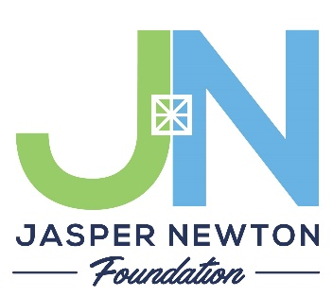
COMMUNITY GRANTS 2024

Application Checklist and Cover Sheet

Submission Guidelines

2024 Community Grant Applications will have three cycles. Applications will be due February 1, May 1, and August 1, 2024. Payouts, if approved, will occur in the month following the grant deadline. If an application is declined during one grant cycle, the organization may reapply in another cycle. However, only one Community Grant can be awarded per year to an individual non-profit. Grants are typically smaller than $5,000. Please submit your grant application and all attachments via email to Ashley Hughes by 5 pm central time on the date the application is due. Type your application so it is easier for the grants committee to review. Also, please save files in PDF format (even if you attach multiple files).

Email your grant application and all attachments to Ashley Hughes, Program Director, at ahughes@jasperfdn.org. After submission, you will receive a confirmation email that your application was received.

Checklist for Submission

I have called the JNF office to speak with the Executive Director about my grant if this is my first grant or if salary dollars are being requested. (Not required for all applicants)

I have filled out the organizational information and program description.

I have obtained the signature of my Board Chair, President, Director, or Principal/Superintendent expressing their knowledge and support of this grant application.

I have fully answered the 4 Grant Narrative Questions.

I have included my Board of Directors listing with officers and contact information.

I have included my program/project budget, including as many details as possible.

I have included my organization’s balance sheet and this year’s operations budget.

I have included a 1-2 paragraph Budget Narrative explaining our budget expenses.

If awarded, I will complete the Final Grant Report as requested by the JNF office staff.

I, __________________________________, certify that I have read and filled out this grant application to completion and followed all the requested steps.

Signature ___________________________________, title _________________________

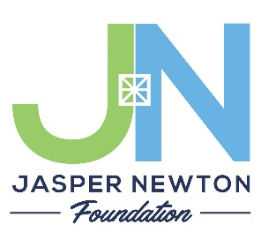
COMMUNITY GRANTS 2024
Application
JASPER COUNTY COMMUNITY FUND
NEWTON COUNTY COMMUNITY FUND
(circle one fund only)
Organizational Information

Legal Name of the Organization
Telephone Number
Website Address
Street Address of Organization
City | State |  | Zip
Mailing Address
(if different than physical address)
City | State |  | Zip
Federal Tax ID (EIN)
Main Contact Person for Grant
Contact Phone Number
Contact Email Address
Signature of Board Chair, President, Director, or Principal/Superintendent expressing their knowledge and support of this grant application

Signature _______________________________________ , title ______________________________

Program Description
Please include a 2-3 sentence summary of the program you are requesting community grant dollars for in the box below. This should be clear and concise.

What area of the community does this grant application seek to serve the most?
____ Vibrant Community (Arts, Culture, Lifestyles)
____ Prosperous Community (Business Development Resources, Employee Training)
____ Quality Life (Access to Health Care & Healthy Life Choices)
____ Kids & Families (Education)

Application Narrative Questions

Please use the following questions in the order shown with an explanation and description so the committee can get a feel for your project and the needs that are being met in the community.

- What project/program will this grant money fund, how much are you requesting, what is your organization’s mission statement and how does it directly link to this project/program?

- What is the implementation plan for your project/program? Please include a timeline of implementation.

- How will your proposed project/program promote sustainable impact towards the betterment of Jasper or Newton County?

- Will funding this project/program likely draw additional funding or partnerships that will bring positive and transformative change to Jasper or Newton County? Please share whom you are partnering with and any matching grant funds you have received. Please address how you will proceed with securing the remaining funds if your total request cannot be provided by a Community Grant from JNF.

Board of Directors Information

Please attach a listing of your current Board of Directors, indicate officer roles, and include a phone number or email address for contacting each member.

Grant Budget

- Provide the entire budget and scope of the project, even if you are only asking JNF for a portion of the project budget itself.
- If securing goods or services, please provide at least 2 quotes. Local sources for quotes are encouraged.
- If purchases will be made online, screenshots or printouts of the website shopping cart are acceptable.
- Grants can be used for supplies, equipment, software, training, and professional development. Salary dollars must flow directly to the person who will execute this specific project and be something a community volunteer cannot do. Salary dollars must be discussed with the JNF Executive Director before submitting an application.
- Attach a copy of your balance sheet and annual organizational budget for the current year.

Sample Budget Request Form
Item | Budget Category  (i.e. supplies, equipment, software…) | Can it be Reused?  Yes/No | Vendor  Attach a copy of the item shown in catalog or online (please e-mail this quote, etc. along with the application to ahughes@jasperfdn.org) | Quantity | Total Cost including shipping
 |  |  | Total Project Budget
***TOTAL AMOUNT REQUESTED FOR JNF COMMUNITY GRANT***

BUDGET NARRATIVE

Please provide 1-2 paragraphs that explain your Grant Budget to fill in storyline gaps.

