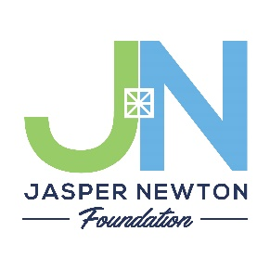
Application for Community Fund Grant
P.O. Box 295 Rensselaer, IN 47978 (219)866.5899 or (219)285.5899
www.jaspernewtonfoundation.org
Due April 1 and October 1 yearly
Please submit to the following location: (circle one) Jasper County or Newton County
Date: __________________________

LEGAL NAME OF AGENCY Requesting Funds:

Federal Tax ID# or EIN#:

Address:

City: Zip Code:

Contact Person

Phone: _________________________ E-mail:

Amount Pertinent
Requested: _______________________ Dates Involved:

PROGRAM DESCRIPTION: (Brief 1-2 sentence summary)

________________________________________________________________________________________________________________________________________________________________________________________________________________________________________________________________________________________________________________________________________________________________________________________________

Have you applied to other agencies or foundations for this project?

Yes ______ No _______ If so, please indicate

FOR OFFICE USE ONLY

Date Received: _______________________ Date Approved:

Category: ____________________________ Date Denied:

Amount Granted: ________________________ Special Conditions:

***PLEASE SUBMIT 6 COMPLETE COPIES OFTHE FOLLOWING:
The application will not be reviewed if ALL sections are not submitted.

Checklist for Complete Submission

- Application (first sheet filled out completely)

- List of Officers and Board Directors with contact information.

- The organizations current year budget and recent Statement of Financial Position.

- A copy of the organizations Federal 501(c)(3) Tax Designation letter from the IRS and copy of most recent IRS 990 tax filing. (To save paper, your IRS Form 990 can be emailed to ahughes@jasperfdn.org)

- Narrative that includes the following sections (no more than 2 pages in length, total):
- Outline of the Project’s Goals and Objectives
- Plan of Implementation
- Project Budget
- Staff who will be facilitating
- Method of Evaluating the successes/shortcomings of the project
- Why this proposal is important to the Community

Name of Project:

Project Goals and Objectives:

Plan of Implementation:

Project Budget: (please include if you will be able to complete the project without full funding from the Foundation)

Staff:

Method of Evaluating Successes/Shortcomings:

Why is this project important to your community?

