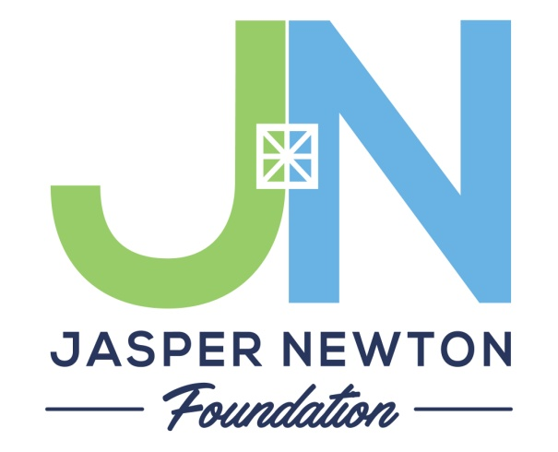
UNRESTRICTED COMMUNITY FUNDS
GRANT APPLICATION GUIDELINES

The Jasper Newton Foundation Inc. accepts grant applications to our respective Community Funds two times each year.
Applications are due April 1 and October 1. Grant awards are announced six weeks after each deadline.

Applying for a Grant from Community Funds
- Grant seekers are strongly encouraged to call the Foundation’s program staff to discuss a grant proposal before submitting a formal application.

- Once you have discussed your proposal idea with the program staff, complete and submit a grant application by the deadline. Application forms are available at our website:
www.jaspernewtonfoundation.org
The Geographic Area We Serve
Jasper County and Newton County

Grant Making Areas of Interest
- Arts & Culture
- Education
- Health/Human Services
- Historic Preservation
- Community Development/Environment

Grant applications are encouraged for types of projects which will:
- Yield substantial benefits to the community for the resources invested
- Promote cooperation among agencies without duplicating services
- Provide “seed money” for innovative community programs
- Encourage matching gifts or additional funding from other donors
- Reach a broad segment of the community with needed services not now being provided
- Build the capacity of the applying organization

The Foundation will focus upon:
- The capital needs of community institutions and organizations
- The emerging needs of Jasper/Newton Counties
- The monitoring of community services to avoid duplication and ineffective programs
- Acting as a catalyst for action and community participation

The Jasper Newton Foundation is located at:
301 N. Van Rensselaer Street
PO Box 295 (for mailing)
Rensselaer, IN 47978
(219)866-5899 or (219)285-5899

The Foundation places low priority on the following, which are unlikely to receive funding:
- Reduction of debt (including payments for items purchased prior to grant approval)
- Travel
- Funding for Salaries
- Attendance at conferences and seminars
- Programs that fall more appropriately under government funding, such as operating expenses for public schools and police or fire protection
- Requests from organizations that have received a Community Funds grant in the past 12 months
- Requests from organizations that have an open Community Funds grant file (i.e. a balance remaining on a previous grant or an unfiled final report)

The Foundation will not consider grants for:
- Individuals
- Political activities or those designated to influence legislation
- National organizations (unless the monies are to be used solely to benefit citizens of Jasper County or Newton County)
- Annual giving campaigns
- Religious organizations for the sole purpose of furthering that religion
- Contributions to endowments

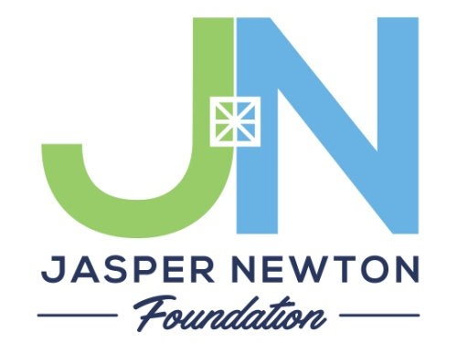

Grant Application Procedure

Grant applications for the Unrestricted Community Grants Cycle may be submitted to the Foundation at any time before the bi-annual due dates of April 1 and October 1. The Grants Committee and the Executive Director will initially review the applications.

Requests for grants are reviewed by the respective Foundation’s staff and Grants Committee. You may receive a phone call or email from one of our Grants Committee members if there are additional questions the group might need an answer for. These contacts are very important and are often the last bits of information needed to make a fair decision. Reviews and recommendations are then presented to the full Board of Directors at the next regularly scheduled meeting at which time all final decisions are made (between 4-6 weeks).

Grant applicants will be notified in writing with respect to the decisions of the Foundation’s Board of Directors. This correspondence will state whether or not a grant was made and will provide specific details for those grants which have been approved. The grant acceptance and final report phase of the April 2017 cycle will be done online. Detailed information on this process will arrive with the grant notification letters. As always, the office staff is happy to help. You can reach out to any of us at (219)866.5899 or (219)285.5899, 8am-4pm central time M-F, at the Carnegie Center in Rensselaer, Indiana (301 N. Van Rensselaer Street).
Jasper Newton Foundation Inc.
P.O. Box 295
301 N. Van Rensselaer St.
Rensselaer, IN 47978

Applications should be mailed or dropped off at:

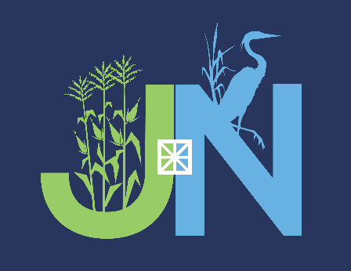

Application for Community Support Grant
P.O. Box 295 Rensselaer, IN 47978 (219)866.5899 or (219)285.5899
www.jaspernewtonfoundation.org
Due April 1 and October 1 yearly
Please submit to the following location: (circle one) Jasper County or Newton County
Date: __________________________

LEGAL NAME OF AGENCY Requesting Funds:

Federal Tax ID# or EIN#:

Address:

City: Zip Code:

Contact Person

Phone: _________________________ E-mail:

Amount Pertinent
Requested: _______________________ Dates Involved:

PROGRAM DESCRIPTION: (Brief 1-2 sentence summary)

_________________________________________________________________________________________________________________________________

_________________________________________________________________________________________________________________________________

Have you applied to other agencies or foundations for this project?

Yes ______ No _______ If so, please indicate

FOR OFFICE USE ONLY

Date Received: _______________________ Date Approved:

Category: ____________________________ Date Denied:

Amount Granted: ________________________ Special Conditions:

***PLEASE SUBMIT 8 COMPLETE COPIES OFTHE FOLLOWING:
The application will not be reviewed if ALL sections are not submitted.

1. Application (first sheet filled out completely)

2. List of Officers and Board Directors.

3. The organizations latest Financial Report.

4. A copy of the organizations Federal 501(c)(3) Tax Designation letter from the IRS.

5. Narrative that includes the following sections (no more than 2 pages in length, total):
- Outline of the Project’s Goals and Objectives
- Plan of Implementation
- Project Budget
- Staff who will be facilitating
- Method of Evaluating the successes/shortcomings of the project
- Why this proposal is important to the Community

Name of Project:

Project Goals and Objectives:

Plan of Implementation:

Project Budget: (please include if you will be able to complete the project without full funding from the Foundation)

Staff:

Method of Evaluating Successes/Shortcomings:

Why is this project important to your community?

