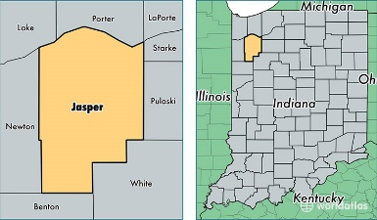
Jasper County Retired Teachers Grant
Active Teacher Grant Application Cover Sheet
Guidelines: The Jasper County Retired Teachers has a grant available. A maximum of $300 will be awarded each year for a teacher in a Jasper County school. These special grants will provide additional funds to public school certified educators (Pre-K through 12) so that their students will have the means to participate in special projects.
Deadline: Application Cover Sheet and Sections 1 through 4 materials must be submitted by September 15th.
Funds: Funds may be appropriated in the areas of resources, leadership, research or materials
Winners: Winners will be notified by October 15th. A one-page follow-up report is requested from the grant recipient by May 1st of the following year.
Thank you for your interest and intent to further the excellence of education in Jasper County. For questions about this application, please contact Bob Souza 219-819-6200.
Application:
Name__________________________________________________________________________
Address________________________________________________________________________
E-mail Address of Applicant____________________________________________________
Applicant Home Phone ( )_____________________
Applicant Cell Phone ( )________________________
Signature of Applicant________________________________________________________
School Corporation___________________________________________________________
School Name__________________________________________________________________
School Address________________________________________________________________
Signature of Principal_________________________________________________________
Name of Local Newspaper_____________________________________________________

JASPER COUNTY
RETIRED TEACERS
Active Teacher Grant Application sections
Section 1. Title and Description
In 50 words or less describe your school or classroom project. Please identify the population involved and include a detailed description of the demographic area for which the funds will be used.
Section 2. Purpose of Project
State the overall goal or objectives for pursuing your project. Explain what you hope to accomplish at the completion of the grant.
Section 3. Evidence of Need
Demonstrate the need for your project.
Section 4. Proposed Budget Explanation
Attach an estimated list of materials and supplies to show how the grant money will be spent.

Application Checklist
Assemble your application in this order.
- Application Cover Sheet.
- Sections 1 through 4 completed and not more than 2 pages. The Application Cover Sheet does not count as the 2-page limit.

REMINDER: You must submit the original cover sheet and sections 1-4. Send 5 copies by September 15th to Jasper County Retired Teachers, c/o Jasper/Newton Foundation, Box 295, Rensselaer, IN 47978.

