Circle One: DeMotte Remington Rensselaer Roselawn Lake Village
Women’s Giving Circle Final Report Form

Deadline: August 1
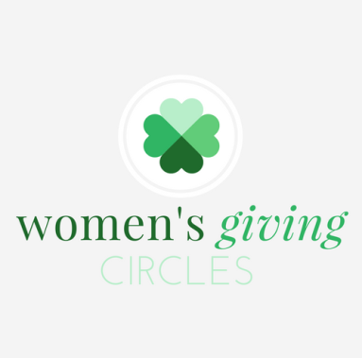

Jasper Foundation, Inc. and Newton County Community Foundation require the submission of a Final Report to your local Women’s Giving Circle upon completion of your grant.

The Grant Report must be submitted by August 1 following the award year. Failure to submit the report on or before the deadline may eliminate your organization from future grant consideration.

The Grant Report requests specific information regarding the total income and expenditures for the program/project funded.

PLEASE PROVIDE THE FOLLOWING:

ORGANIZATION
Legal Name of Organization Website Address
Street Address City State Zip Code
Mailing Address (if Post Office Box) City State Zip Code

CONTACT
Contact Name Title
Primary Telephone Number Email Address
Alternate Telephone Number Alternate Email Address

PROGRAM/PROJECT INFORMATION
Program/Project Title
Briefly share the outcomes/impact of your program/project including relevant statistics on how the community at large was impacted. (Maximum of 200 words)

How did your program/project empower/strengthen those it aimed to serve? Please share the geographic location and age range of the audience served. (Maximum of 150 words)

Describe any challenges encountered and explain how they were overcome. (Maximum of 150 words)

Did your organization partner with another organization(s) to facilitate this program/project? If yes, provide details. (Maximum 150 words)

REVENUE AND EXPENDITURES
ATTACHMENT: Program/Project Financial Report (sample provided below)
Provide the program/project income and expenditures, specifically how the grant funding was utilized.

You may provide your financial report in one of the following ways:
- Complete the provided Financial Report
  - You will need to save this completed file and attach it to your application
- Attach your own report. Be sure that your report includes the type of information requested on the "Financial Report".

Grant Amount Received
Grant Amount Spent If you did not spend all of grant amount received, provide explanation.

Did receiving this Jasper Foundation, Inc. or Newton County Community Foundation grant award help your organization secure any additional funding or matching funds? If yes, provide details. (Maximum 150 words)

SUPPLEMENTAL MATERIALS
ATTACHMENT(S): Supplemental Items (Provide information regarding your program/project. Examples: participant survey responses, event agenda or program, speaker profile, etc. Opportunity to provide four attachments.)

ATTACHMENT(S): Publicity/Media Coverage (Provide publicity regarding program/project. Specifically, items including Jasper Foundation, Inc. or Newton County Community Foundation’s support regarding this grant. Opportunity to provide four attachments.)

ATTACHMENT(S): Photographs (Provide program /project related photographs. Opportunity to provide four photo attachments and descriptions.)

REPORT CERTIFICATION AND SUBMISSION VERIFICATION
I hereby affirm that the information provided on and through this report is accurate and complete to the best of my knowledge. I also understand that falsification of information contained in this report may result in the grantee organization being deemed ineligible for future grant consideration. Further, I agree to provide additional documentation supporting outcomes and/or expenditures of this program/project upon request from Jasper Foundation, Inc. or Newton County Community Foundation.

Name of Person Submitting Report Title

Sample Program/Project Financial Report:

Jasper Foundation, Inc. | Newton County Community Foundation
Women’s Giving Circle Financial Report
Organization Name
Program/Project Title
Income
Women’s Giving Circle Grant |  |  | $ -
Expenses
 |  |  |  | $ -
 |  |  |  | $ -
 |  |  |  | $ -
 |  |  |  | $ -
 |  |  |  | $ -
 |  |  |  | $ -
 | Total Expenses |  |  | $ -
Grant Income vs. Expenditures |  |  |  | $ -

